Kingston NV2 PCIe 4.0 NVMe M.2 2280 SSD 1TB - SNV2S/1000G (CZONE)

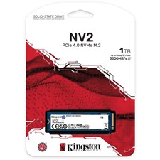

**Key Features**

* **Massive 24TB Storage**: The drive provides an impressive 24 terabytes of storage space, allowing users to store and back up large files, such as high-resolution videos, large databases, and more.
* **USB-C 3.2 Gen 2 Compatibility**: The drive features USB-C (USB 3.2 Gen 2) connectivity, offering fast data transfer rates of up to 10Gbps, ensuring smooth and fast access to large files.
* **High-Speed Performance**: Thanks to its 7200 RPM hard disk and advanced cache management, the drive delivers quick read/write speeds, making it suitable for tasks such as video editing and heavy file transfers.

**Performance**

* **7200 RPM Drive**: The drive's internal 7200 RPM hard drive ensures fast access speeds for handling large files and performing intensive tasks like video editing, graphic design, and more.
* **10Gbps Data Transfer Rate**: With USB 3.2 Gen 2 support, it offers a transfer rate of up to 10Gbps, allowing faster copying, saving, and retrieval of data.

**Warranty and Support**

* **Limited 5-Year Warranty**: The LaCie 24TB d2 comes with a 5-year warranty, ensuring peace of mind for professionals relying on the drive for critical data storage.
* **Data Recovery Service**: The one-year Rescue Data Recovery Service provides additional support in case of data loss, helping to retrieve lost files due to accidental deletion or drive failure.